Qdrant BM25 Search
Dense and Sparse Vectors
1. What are dense vectors?
- Produced by the embedding model (currently: nomic-embed-text) which are a transformer-based model
- The model reads the chunk text and outputs a dense vector: a list of floating point numbers (say 768 or 1024 dimensions).
- Every dimension has a value. They capture semantic meaning via weights in a neural net.
2. What are sparse vectors?
- Sparse vectors are a high dimensional vector representation that store only non-zeros entries to save memory and computation. Each dimension is corresponds directly to a known word or token. That is why it is called sparse.
- For every element dense vectors from models (like Ollama, OpenAI) contain non-zero values
- Since sparse vectors focuses on relative word weights per document with most values being zero, it is more efficient specially in text-heavy search
- sparse vectors shine in domains and scenarios where rare keywords or specialized terms are present.
3. What does Qdrant/BM25 model do?
- About BM25:
- BM25 is the most successful practical instantiation (implementation) of the PRF (Probabilistic Relevance Framework). BM25 is derived directly from the mathematical steps of the PRF.
- The PRF starts with the probability of relevance. It makes assumptions about term independence and "eliteness" (whether a document is "about" a term).
- It approximates the resulting complex probability functions with simpler, tractable formulas.
  - Formula:
- Document length refers to the total size of the entire document before any chunking or splitting into smaller retrieval units. This length is used to normalize term frequencies (tf) to prevent longer documents from receiving artificially high scores simply because they contain more words. The formula applies a "soft normalisation" based on the ratio of the document's length to the average document length in the collection (avdl).
- [Source: foundations_bm25_review (Page 29, 30)]

- About Qdrant/BM25 :
- It is a pre-trained, static model. The model maps each token into an integer ID.
- BM25 (Best Matching 25) is a bag-of-word retrieval function that scores a document D against a query Q.
- The model itself doesn’t compute the full BM25 score. It produces the sparse representation (term frequencies and related weights), while Qdrant applies the IDF (Inverse Document Frequency (Source: irbookonlinereading.pdf, page: 155, 156)) modifier (modifier="idf") during indexing/search to complete the BM25 scoring.
- During indexing it works as follows:
  - Qdrant/bm25 has a fixed vocabulary/tokenizer (exact vocabulary size is not officially documented).
    - It tokenizes the input text.
    - Each token corresponds to a vocabulary dimension (an integer ID).
  - It receives a chunk of text.
  - The text is tokenized.
    - Tokens that exist in the vocabulary are mapped to their vocabulary indices.
    - These become the indices of the sparse vector.
  - It computes a weight for each token.
    - The weight is inspired by BM25 and depends on factors such as the token frequency within the chunk (using the BM25 formula above).
    - These weights become the values of the sparse vector.
- The sparse vector is based on normalized/stemmed lexical terms, not the raw surface words for example: (In Python Notebook)
- Because the stemming helps match different word forms. For example:

Behind the scenes of the Embedder
- Split the Article by chunks (Chunk 1, 2, 3, ...). Each chunk becomes one Qdrant point.
- Each chunk is enriched with a headers like: Title, Section () and Content. These are the exact string that gets embedded.
- The result is a list of PointStruct objects, each representing one chunk with its own ID, two vectors (dense, sparse), and payload metadata. These points are upserted into Qdrant.
- Chunks from the same article are not merged or grouped inside the vector store, instead they only share the same article_id in their payload.
- Therefore, a chunk from Article A may be close to a chunk from Article B if their meanings are similar.

How does the hybrid search happens?
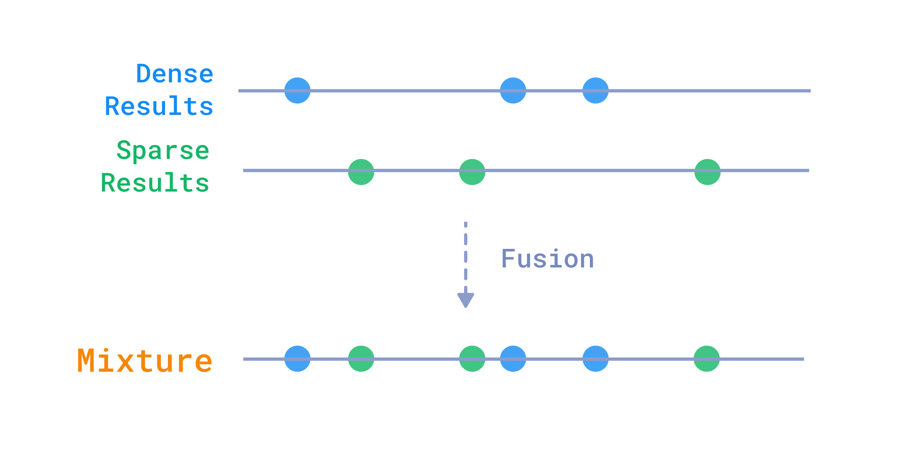
Figure 1: Hybrid Search [https://qdrant.tech/documentation/search/hybrid-queries/]
- Two independent search happens
- Dense Search
  - Uses HNSW (Hierarchical Navigable Small World) graph
    - [Source: Hierarchical Navigable Small World graphs.pdf, page: 1]
  - Nearest Neighbors
  - Cosine similarity
  - Top 50
- Sparse search
  - Query
  - Sparse embedding (indices + values)
  - Posting lists (or inverted index)
    - Each postings list stores the list of documents in which a term occurs, and may store other information such as the term frequency (the frequency of each term in each document) or the position(s) of the term in each document. (Source: irbookonlinereading.pdf, page: 45, 47, 155, 156)
  - Candidate generation
    - Say we have 3 document’s sparse representation:
      - id_1: [(6, 1.0), (12, 2.0)]
      - id_2: [(1, 0.2), (7, 1.0)]
      - id_3: [(6, 0.3), (7, 2.0), (12, -0.5)]
    - The Inverse Document Frequency (mapping from ) could look like the following:
    - 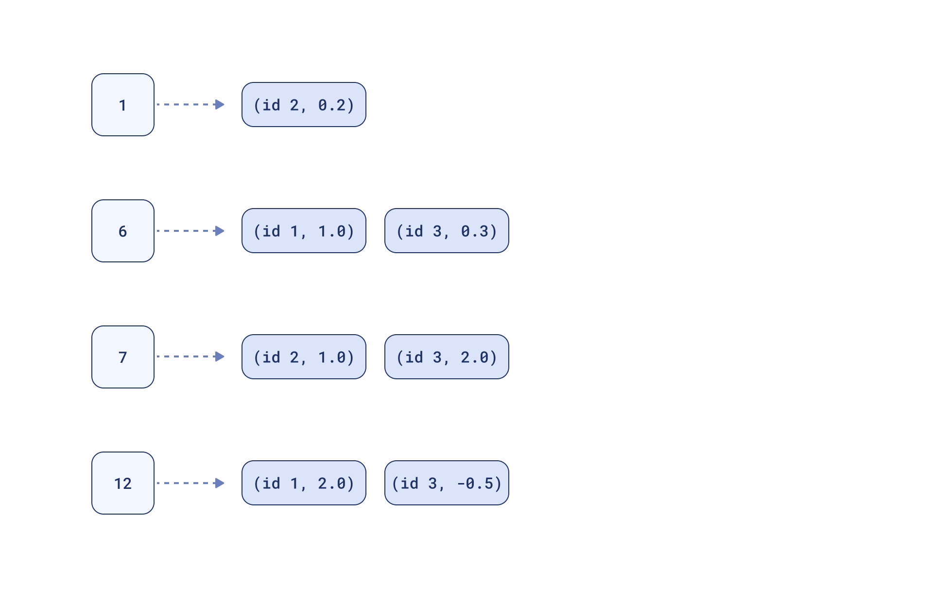
    - Example: If the query is: [(6, 1.0), (7, 2.0)]
      - The system uses the indices 6 and 7 to look up the inverted index map
      - Retrieves the list of all documents (vectors) that have a non-zero value at index 6.
      - Retrieves the list of all documents that have a non-zero value at index 7.
      - It retrieves the following:
        - id_1: (6, 1.0)
        - id_2: (7, 1.0)
        - id_3: [(6, 0.3), (7, 2.0)]
      - Note: The documents that do not contain index 6 or index 7 are immediately discarded because their dot product with the query would be zero.
    - In case of Qdrant it is:
      - dimension_index -> [(point_id, weight)]
  - Sparse similarity (it is always measured by the dot product)
    - Now it calculates the dot product
      - id_1: (6: 1.0*1.0) = 1.0
      - id_2: (7: 2.0*1.0) = 2.0
      - id_3: (6: 1.0*0.3) + (7: 2.0*2.0) = 0.3 + 4.0 = 4.3
  - Return top N documents
    - The candidates are sorted by their calculated scores in descending order, and the top (50 in our case) results are returned to the user.
- Source: https://qdrant.tech/course/essentials/day-3/sparse-vectors/
Q. What is Fusion ?
- Reciprocal Rank Fusion (RRF) [Source: cormacksigir09-rrf]
- We retrieve separate result lists from the dense (semantic) and sparse (keyword) queries
- Each retrieval method produces a numerical score assigned to each document it selects. These scores can’t be directly compared to each other between different methods, so there is no clear way to mix candidates. [Source: https://qdrant.tech/course/essentials/day-3/hybrid-search/]
- Then Qdrant uses the Query API with a prefetch mechanism to run both searches in parallel and then applies a fusion algorithm to combine the ranked lists.
- The mathematical formula is as follow:
  - ...
  - Qdrant uses a default RRF constant of k = 2 [Source: https://qdrant.tech/documentation/search/hybrid-queries/#reciprocal-rank-fusion-rrf:~:text=Reciprocal%20Rank%20Fusion,2%20by%20default]
- RRF rewards agreement between rankers, not the loudness of any single vote. That means, a document that nobody hates and that several systems consider decent will beat a document that one system worships and another despises. [Source: https://blog.serghei.pl/posts/reciprocal-rank-fusion-explained/]

RAG Evaluation
- Evaluating with RAGAs
- Evaluating the following metrices
  - Faithfulness
    - Measures LLM’s faithfulness to the retrieved contexts
  - AnswerRelevancy
    - Checks if LLM’s response is relevant to the user’s question
  - ContextRecall
    - Measures whether the retrieved contexts contains the answer to the user’s question or not
  - LLMContextPrecisionWithReference
    - Measures whether the retrieved contexts are relevant to the user's question and the LLM's response

Q. How is RAG evaluated? What frameworks are used? Why using RAGAs?
Paper: Retrieval Augmented Generation Evaluation in the Era of Large Language Models: A Comprehensive Survey

